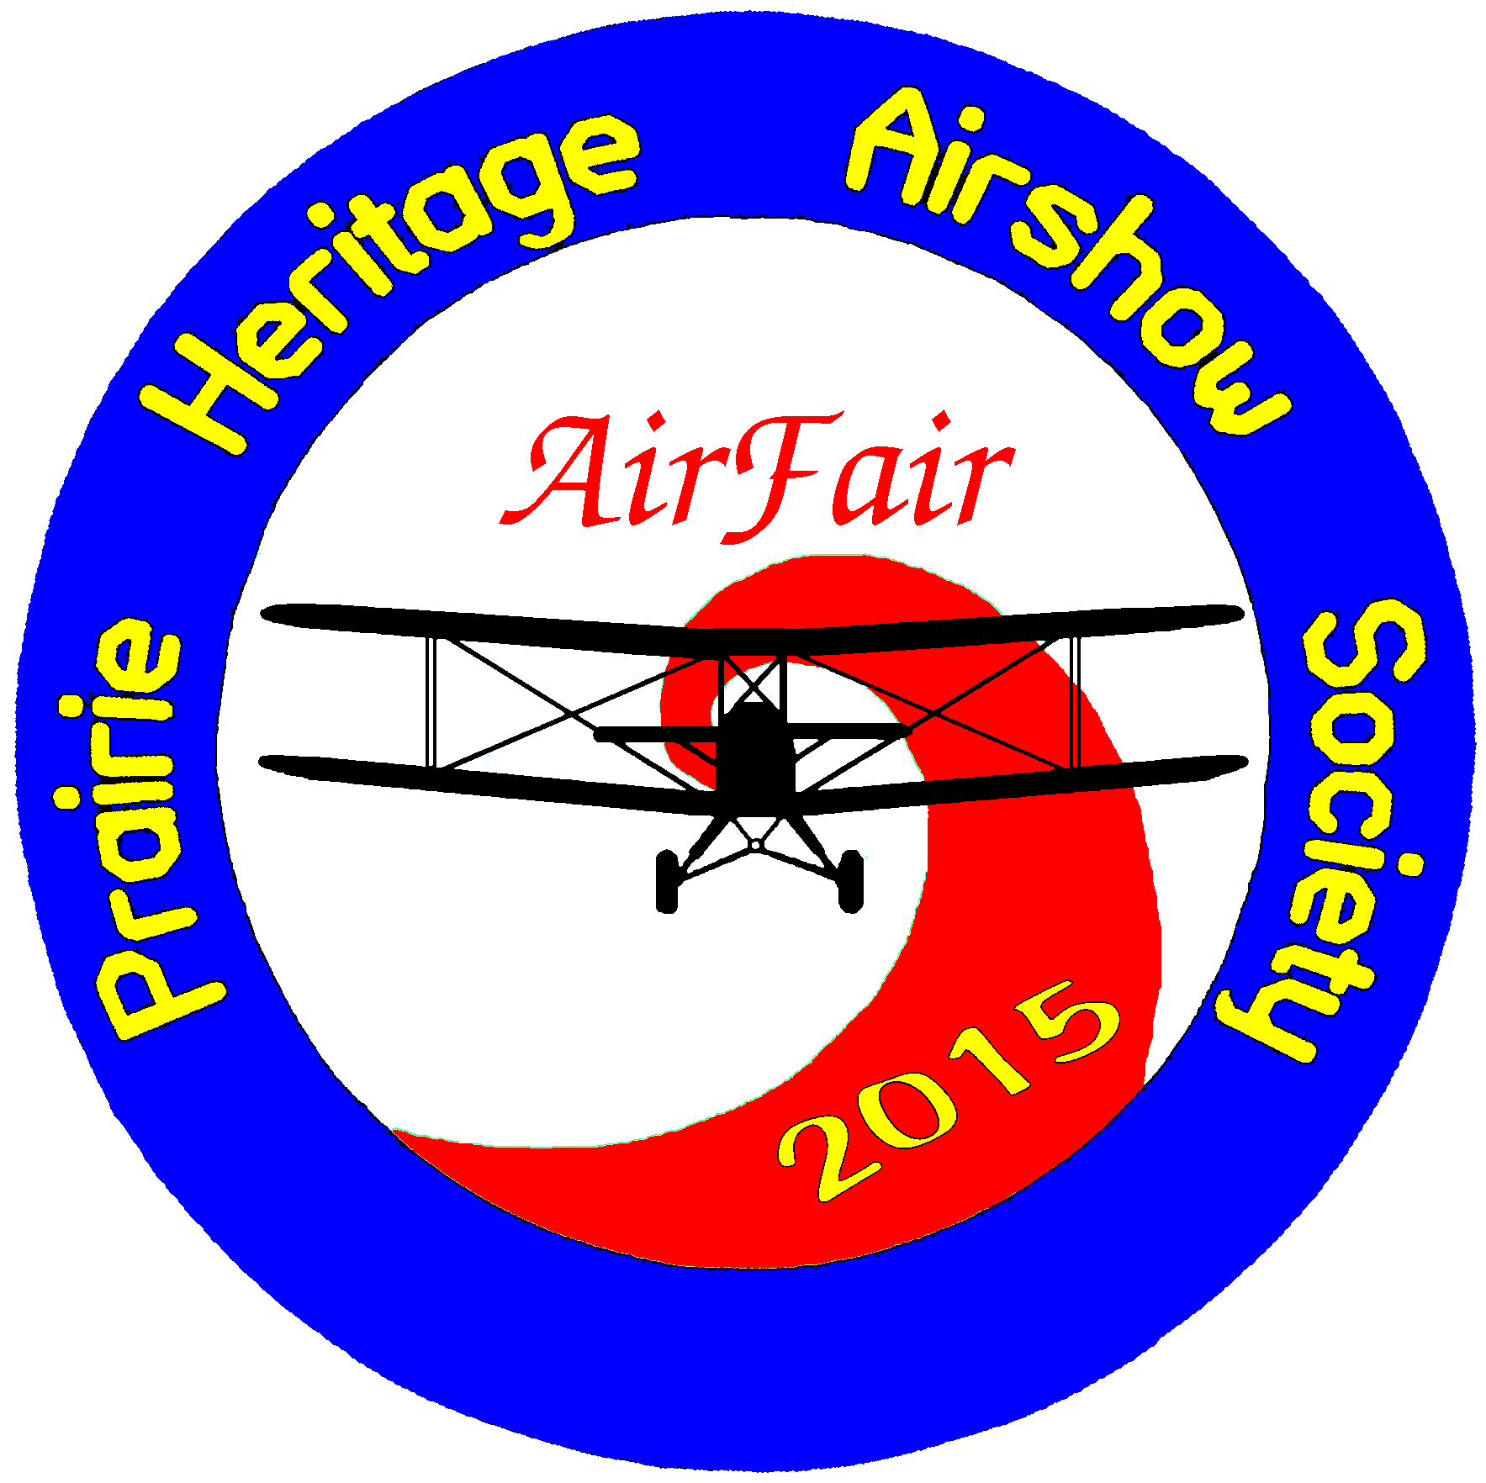 |  | AirFair 2015 Vendor Contract  July 15, 16, 17, 2015
 |  | Vendor Information .
______________________________  Company Name  _______________________________  Contact Person  ________________________________  Email  ____________________________________  Phone/ Fax |  |  | ____________________________________  Address  ____________________________________  City, Province  ____________________________________  Postal Code
Please indicate your vendor type:  - Not for profit display space: FREE (includes static displays)  - Vendors selling food or product: $200 per day (Tues and Thursday) or $500 for all 3 days  - Vendors choosing to come on Wednesday only - $300 |  |  | The Prince Albert Heritage Airshow Society does not supply any amenities, power or water.  You are responsible for supplying your own tents, tables, chairs etc.  All spaces can be doubled in size for double the price.
Vendor Description  Please give a brief description of the products or services that you wish to supply at your booth. This includes raffles/draws/give-aways/contests and sales.  Food vendors must adhere to and provide a copy of the Saskatchewan Health Region Services, Prince Albert Region safe food handling practices and fill out a participant application form for special event and trade shows as attached. Prince Albert Business Licence is required. Please contact Heather at 306-954-4384 |  |  | _________________________________________________  _________________________________________________  _________________________________________________  _________________________________________________  _________________________________________________  This application must be returned with full payment by June 15, 2015 to confirm space at the 2015 AirFair.  We will endeavour to allocate your space to create the most effective show.
Page 1 of 2 www.centennialofflight.ca July 16-17, 2015
 | Page 2 of 2 www.centennialofflight.ca July 16-17, 2015

We, the undersigned, agree to pay the Prairie Heritage Airshow Society (the Licensor) the appropriate space rate, GST included. We have read and understand the conditions of the application/contract on the reverse, and agree to abide by them. Faxed copies will be considered as an original application/contract with payment.
Please consider that your space is not reserved until full payment has been made.
Payment is due by June 30, 2015.
Cheques can be made payable to the Prairie Heritage Airshow Society (PHASS).

______________________________________  Authorized Vendor Signature  _______________________________________  Please Print Name  _______________________________________  PHASS Representative Signature | _________________________________  Cheque Amount  _________________________________  Date Received  _________________________________  Receivers Signature
Please make cheques payable to the Prairie Heritage Airshow Society.  Cheques or money orders can be mailed with this form to:  Prairie Heritage Airshow Society  10 River Street East, Prince Albert, Sk  S6V 8A9 | If you have questions, please contact;  Debbie Honch @ 306-960-7039  Or honch@sasktel.net

Contract/Space Application: READ CAREFULLY

These regulations have been established for the mutual benefit and protection of exhibitors/visitors of AirFair 2015.
1. Show move in 9:00am – noon – Tuesday July 14, Wednesday, July 15 and Thursday, July 15
2. Show move out times – directly after the shows. There will not be any security over night.
3. Show Days: July 14-16, 2015 - Gates open at noon, afternoon static and flight, aerial show in evenings, gates close at 8:00pm, Tuesday and Thursday, 9pm on Wednesday.
4. You are paying for space only; tables/chairs/tents are to be brought by you. No power or water supplied
5. Exhibitor agrees there will be NO subletting of their booth space.
6. Liability – Although security will be there through-out the air show, the AirFair 2015 Air Show and their volunteers can or will not be responsible for damage to, loss or theft of property belonging to, or injury to, any exhibitor, his agents, or employees. Each exhibitor is expected to carry his appropriate insurance. Upon signing this contract, exhibitor is signing a release.
7. Cancellation – in the event that this application is not accepted, space rental fees paid to the Prairie Heritage Airshow Society will be returned. After acceptance of the application by the show, no amount paid or payable by the exhibitor is refundable in the event the exhibitor does not use the reserved space. The AirFair 2015 Show shall have full power to interpretation and enforcement of all rules and regulations contained herein.
8. Each 10’ x 10’ booth will receive 3 exhibitor passes to the Air Show that must be worn at all times. These do not give you admittance into any restricted or VIP areas. Exhibitors and all exhibitor materials must remain with-in the allotted space.
9. By signing this contract/space application, I am indicating that I have read the full contract and agree to all of the regulations of the Centennial of Flight Air Show and sign the contract of my own free will.

Please sign at the top of this page.

